WPS Canteen Menu - 2023

Sandwiches, Rolls and Wraps

 | Sandwich | Wrap
Plain – butter only | $2.00
Vegemite | $2.00
Cheese/ Tuna/ Ham / Chicken / Egg /Salad only | $3.00 | 4.00
EXTRAS 50c each - lettuce, tomato, grated carrot, beetroot, cheese, sauce, mayo or dijonnaise

Toastie
One Filling $3.50
Cheese or Baked Beans
Two Fillings $4.00
Chicken or Ham with Cheese;
Cheese or Chicken or Ham with Tomato
Baked Beans & Cheese
Three Fillings $4. 50
Chicken or Ham with Cheese & Tomato

Snacks available over-the-counter only
UFO, frozen pineapple ring $0.50
Muffin, regular $1.00
Chocolate Cookies $0.50
Mamee Snacks $1.00
Assorted Chips (Red Rock & Smiths 85g) $1.50
Custard (vanilla) $2.00

Icecreams available over-the-counter only
Various From $1 to $2

Drinks
Water, 600ml $1.50
Flavoured Milk, 250ml $3.50
Strawberry or chocolate
Juice, 100% juice, 250ml $2.00 Apple & Blackcurrant, Orange, Apple

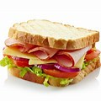
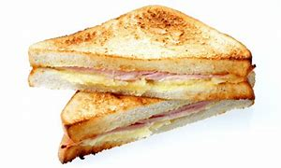
Salad Box
Salad Box *GF $5.50
Lettuce, tomato, carrot, beetroot with one of the following: Tuna, Chicken, Ham; Egg or Cheese

Hot Food
Condiments: tomato sauce, mayo or dijonnaise $0.30
Cheese $0.60

Wedges $3.50
Extras- sweet chilli and/or sour cream each $0.50

Hash Brown *GF $1.50

Hotdog $4.50

Chicken Burger - Chicken Pattie with $6.00
Lettuce, sliced tomato, grated carrot, mayo or tomato sauce

Chicken Breast Nuggets - 5 per serve $5.00

Pasta Spaghetti Bolognaise $6.50
Macaroni Cheese 200g (no meat) $6.50
Lasagne, beef, 200g $6.50

Pizza Home Made/Freshly Made
Create your own pizza, toppings below $4.50
Choose from tomato, cheese, pineapple, capsicum, onion, ham, chicken

Pastries (reduced fat and salt range)
Pasty $5.00
Sausage Roll $5.00
Pie $5.00

Cup of Noodles chicken flavour $4.00

Nachos – Tuesday only
Additional Toppings $3.00
Extras - sweet chilli and/or sour cream each $0.50
*GF – Gluten Free

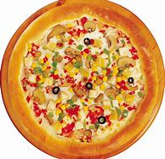

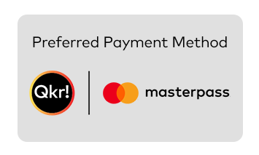
ORDERING YOUR LUNCH

TO ORDER LUNCH...:
• Place order via Qkr app by 9:00am or place lunch bags in the class lunch order box by 9:00am
• Lunch orders received after 11.00 am will comprise of a vegemite or buttered sandwich.

NOTES...
• If a child does not receive all of his/her lunch order they should go to the canteen on the day with their lunch order bag so it can be organised
• Children who have no lunch at school will be supplied with a basic sandwich at $3.00
• Children who go home sick should let the canteen know via their teacher if they have a lunch order so that it can be cancelled
• The Canteen sub-committee reserves the right to alter prices

LUNCH BAGS...
• Please order lunch using a PAPER LUNCH BAG or via the Qkr App - NO plastic or envelopes
• Lunch bags are sold from the canteen, minimum purchase 4 bags for 30 cents.

CANTEEN TIMES Tuesday to Friday - CLOSED ON MONDAYS
Recess: 10.30am to 11.00 a.m.
Lunch: 1.00pm-1.15pm
The Canteen Manager is in attendance from 8.30 am to 2.00 pm

PARENT/CARER HELPERS...
• Our canteen is able to be maintained because of the generous help from our parent and carer volunteers
• We require helpers at the canteen from 9:00am to 1:30pm Tuesday to Friday
- Please contact the front office if you would like to apply to volunteer
• Once rostered to volunteer please let Lee Linke know if you are unable to attend on your rostered day
• In thanks, all parent helpers are entitled to a food item of their choice (subject to availability) as well as tea or coffee at no charge.

PARENT HELP IS ALWAYS APPRECIATED AND IS ESSENTIAL FOR THE EFFICIENT RUNNING OF THE CANTEEN

WOODVILLE PRIMARY SCHOOL—Telephone 8445 2744

